**Task 2:- Basic & Advanced Analysis**

1 Write a query to display the Customer Name and Customer Segment using alias

Name “Customer Name", "Customer Segment" from table Cust_dimen.

Q) SELECT Customer Name AS 'Customer Name’, Customer Segment AS 'Customer Segment ‘FROM Cust_dimen;

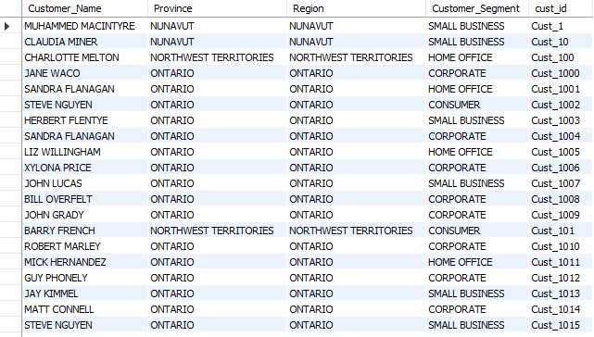

2) Write a query to find all the details of the customer from the table cust_dimen order by desc

Select * from cust_dimen order by cust_id desc;

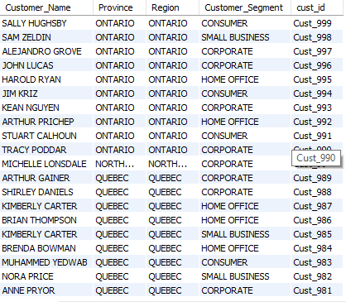

3) Write a query to get the Order ID, Order date from table orders_dimen where ‘Order Priority’ is high.

select order_id,order_date from orders_dimen where order_priority = 'high';

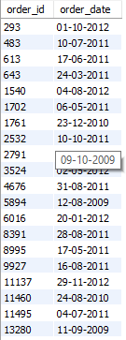

4) Find the total and the average sales (display total_sales and avg_sales)

select avg(sales) as average,sum(sales) as total_sales from market_fact;



5. Write a query to get the maximum and minimum sales from maket_fact table.

select max(sales) as maximum, min(sales) as minimum from market_fact;



6. Display the number of customers in each region in decreasing order of no_of_customers. The result should contain columns Region, no_of_customer

SELECT region, COUNT(Cust_id) AS 'no_of_customers'FROM cust_dimen GROUP BY region ORDER BY COUNT(Cust_id) DESC;

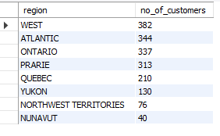

#7. Find the region having maximum customers (display the region name and max(no_of_customers)

select region,count(cust_id) as no_of_customers from cust_dimen group by region order by cust_id desc limit 1;



8.Find all the customers from Atlantic region who have ever purchased ‘TABLES’ and the number of tables purchased

#(display the customer name, no_of_tables purchased)

SELECT c.customer_name AS 'customer name',region,p.Product_Sub_Category,SUM(m.Order_Quantity)FROM cust_dimen c

INNER JOIN market_fact m ON c.Cust_id = m.Cust_id INNER JOIN

prod_dimen p ON p.Prod_id = m.Prod_id WHERE region = 'Atlantic'AND p.Product_Sub_Category = 'TABLES'

GROUP BY c.Customer_Name

ORDER BY SUM(m.Order_Quantity) DESC;

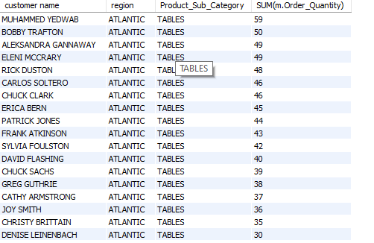

#9 Find all the customers from Ontario province who own Small Business. (display the customer name, no of small business owners)

select customer_name,province,customer_segment from cust_dimen where region='ontario' and customer_segment='small business';

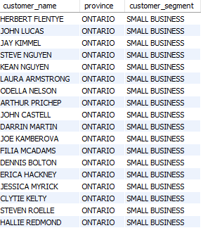

#10 Find the number and id of products sold in decreasing order of products sold (display product id, no_of_products sold)

select prod_id,sum(order_quantity) from market_fact group by prod_id order by order_quantity desc;

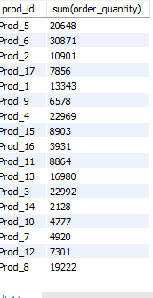

11. Display product Id and product sub category whose produt category belongs to Furniture and Technlogy.

# The result should contain columns product id, product sub category

select prod_id,product_sub_category from prod_dimen where product_category in ('furniture' and'technology');

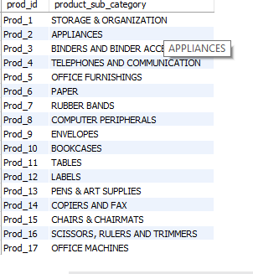

# 12 Display the product categories in descending order of profits (display the product category wise profits i.e. product_category, profits)?

SELECT p.product_category, SUM(m.profit) AS profits FROM market_fact m

INNER JOIN prod_dimen p ON m.prod_id = p.prod_id

GROUP BY p.product_category

ORDER BY profits DESC;

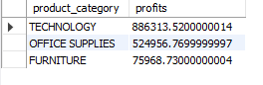

#13 . Display the product category, product sub-category and the profit within each subcategory in three columns

SELECT p.product_category, p.product_sub_category, SUM(m.profit) AS profits FROM market_fact m

INNER JOIN prod_dimen p ON m.prod_id = p.prod_id GROUP BY p.product_category, p.product_sub_category;

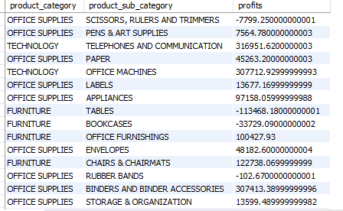

#14 Display the order date, order quantity and the sales for the order.

select a.order_date, b.order_quantity ,b.sales from orders_dimen a INNER JOIN market_fact b ON a.ord_id=b.ord_id;

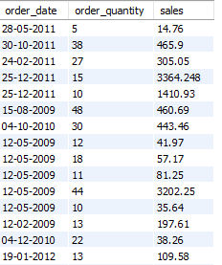

#15 Display the names of the customers whose name contains the

# i) Second letter as ‘R’

#ii) Fourth letter as ‘D

select customer_name from cust_dimen where customer_name like '_r%';

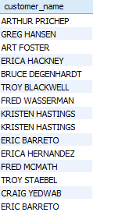

select customer_name from cust_dimen where customer_name like '___d%';

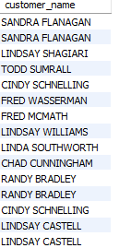

#16 Write a SQL query to to make a list with Cust_Id, Sales, Customer Name and their region where sales are between 1000 and 5000.

SELECT b.cust_id,b.customer_name,b.region,a.sales FROM cust_dimen b

INNER JOIN market_fact a WHERE b.cust_id=a.cust_id AND a.sales BETWEEN 1000 AND 5000;

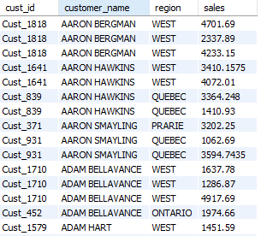

#17. Write a SQL query to find the 3rd highest sales.

select sales from market_fact order by sales desc limit 2,1;



#18 Where is the least profitable product subcategory shipped the most? For the least profitable product sub-category, display the region-wise no_of_shipments and the #profit made in each region in decreasing order of profits (i.e. region, no_of_shipments, profit_in_each_rgion)

SELECT

c.region, COUNT(distinct s.ship_id) AS no_of_shipments, SUM(m.profit) AS profit_in_each_region

FROM

market_fact m

INNER JOIN

cust_dimen c ON m.cust_id = c.cust_id

INNER JOIN

shipping_dimen s ON m.ship_id = s.ship_id

INNER JOIN

prod_dimen p ON m.prod_id = p.prod_id

WHERE

p.product_sub_category IN ( SELECT p.product_sub_category FROM market_fact m INNER JOIN prod_dimen p ON m.prod_id = p.prod_id GROUP BY p.product_sub_category HAVING SUM(m.profit) <= ALL

( SELECT

SUM(m.profit) AS profits

FROM

market_fact m

INNER JOIN

prod_dimen p ON m.prod_id = p.prod_id

GROUP BY p.product_sub_category

)

)

GROUP BY c.region

ORDER BY profit_in_each_region DESC;

